**Interactive Quiz App**

**Project Synopsis**

Project Work Phase - 1 (ECS799)

**BACHELOR OF TECHNOLOGY (CSE)**

|  |  |
| --- | --- |
| PROJECT GUIDE:  **Mr. Rupal Gupta** | SUBMITTED BY:  **Udit Gupta (TCA2009044)**  **Sofiya Chaudhary (TCA2009041)**  **Nikunj (TCA2009030)** |

2023 - 2024



**FACULTY OF ENGINEERING & COMPUTING SCIENCES**

**TEERTHANKER MAHAVEER UNIVERSITY, MORADABAD**

Table of Contents

1 Project Title 3

2 Domain 3

3 Problem Statement 3

4 Project Description 3

4.1 Scope of the Work 3

4.2 Project Modules 4

5 Implementation Methodology 4

5.1 Entity-Relationship Diagram 4

5.2 Data Flow Diagram (DFD) 5

5.2.0 Level 0 DFD 5

5.2.1 Level 1 DFD 6

5.2.2 Level 2 DFD 7

6 Technologies to be used 7

6.1 Front-end – ReactJs 7

6.2 Back-end – NodeJs, ExpressJs 7

6.3 Database - MongoDB 7

7 Advantages of this Project 8

8 Future Scope and further enhancement of the Project 8

9 Conclusion 8

# Project Title

Interactive Quiz App

# Domain

Quiz Application

# Problem Statement

The education industry lacks a comprehensive and user-friendly digital platform for educators to create, manage, and conduct quizzes, and for students to efficiently participate in and track their performance in quizzes. Existing solutions often lack key features, scalability, or user-friendliness, resulting in a need for a robust and accessible quiz application that bridges the gap between teachers and students.

# Project Description

## Scope of the Work

The scope of this project encompasses the development of a comprehensive Quiz Application designed to facilitate the creation, management, and participation in quizzes. The primary objectives include:

* **Teacher Module:** This module enables teachers to register, create quizzes, manage quiz configurations, and review student scores. Teachers can also authenticate themselves using a secure login mechanism.
* **Student Module:** Students can register, join quizzes using game codes, and participate in quizzes. They can also view their scores and progress within the application. Similar to teachers, students will have secure login functionality.
* **Database Integration:** The application will integrate with a backend database for storing user profiles, quiz data, questions, options, and scores. It ensures data integrity and facilitates retrieval.

## Project Modules

The project consists of the following modules:

* **Teacher Module:**
  + Teacher Registration
  + Secure Teacher Login
  + Quiz Creation and Management
  + Student Score Review
* **Student Module:**
  + Student Registration
  + Secure Student Login
  + Quiz Participation
  + View Scores and Progress
* **Database Integration:**
  + Data Storage
  + Data Retrieval

# Implementation Methodology

## Entity-Relationship Diagram

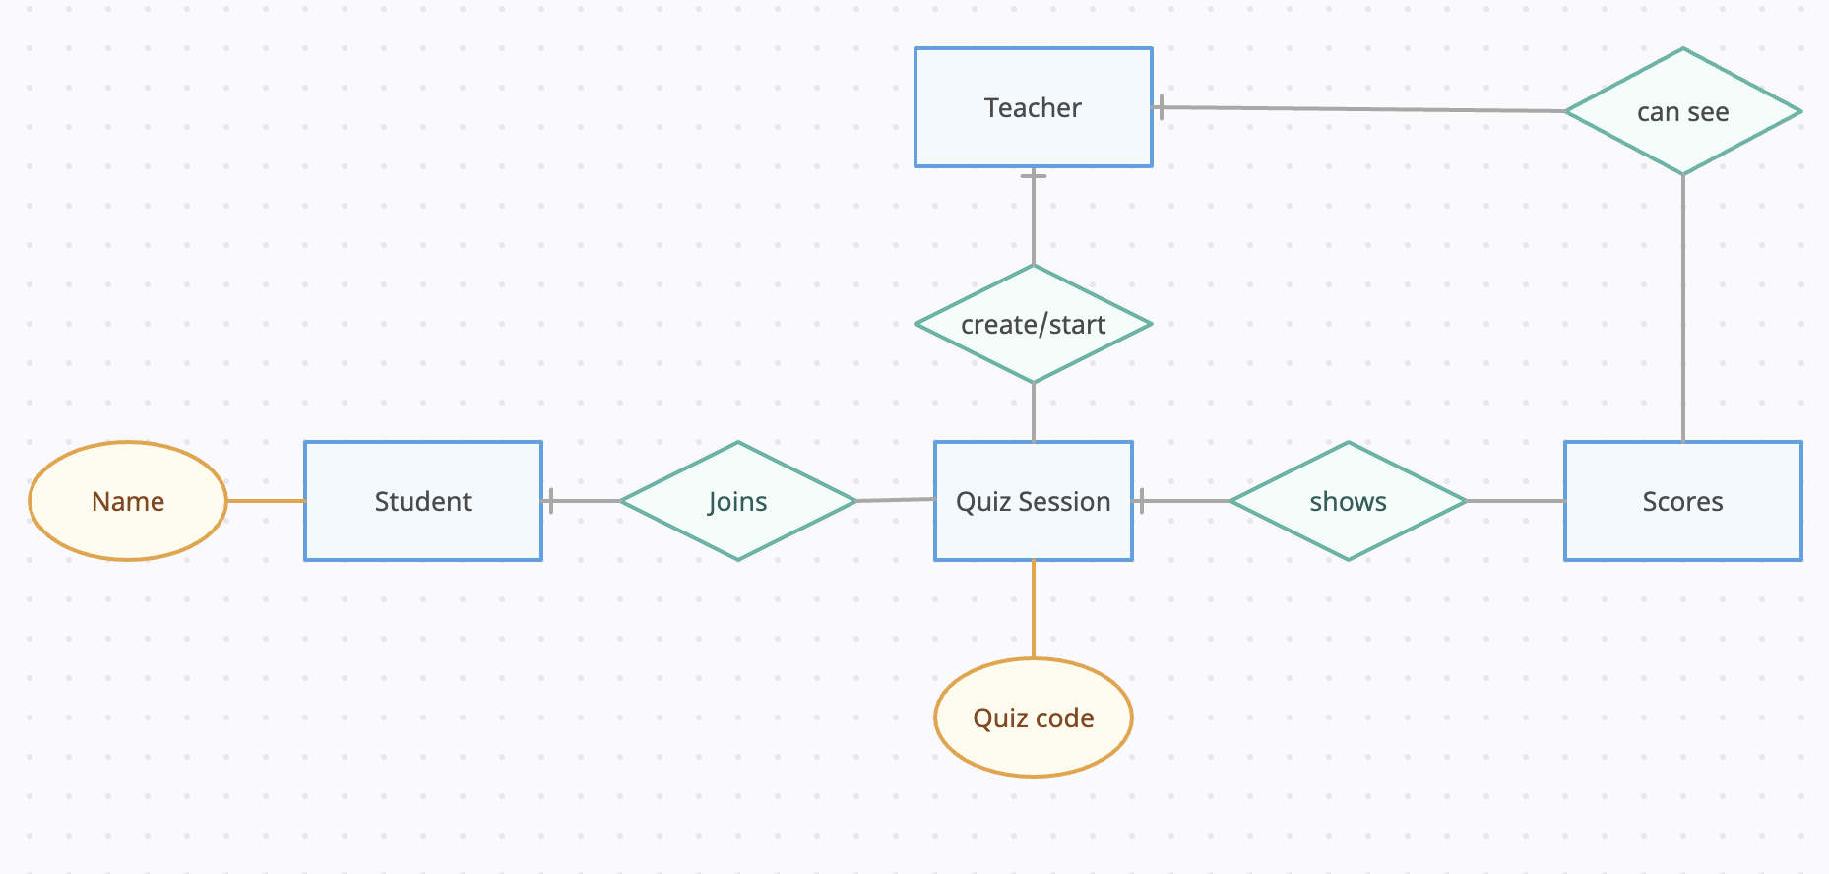

## Data Flow Diagram (DFD)

### Level 0 DFD

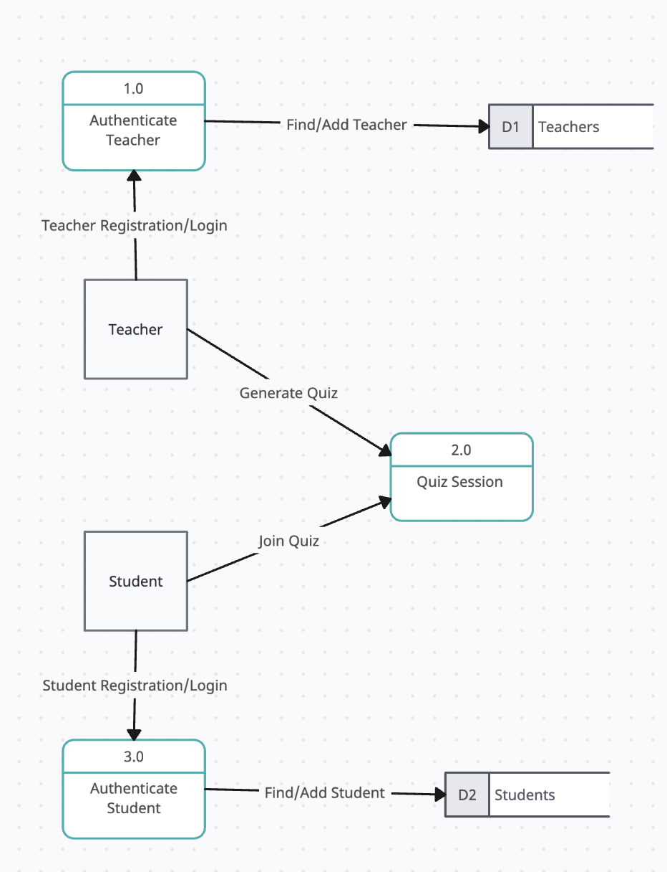

### **Level 1 DFD**

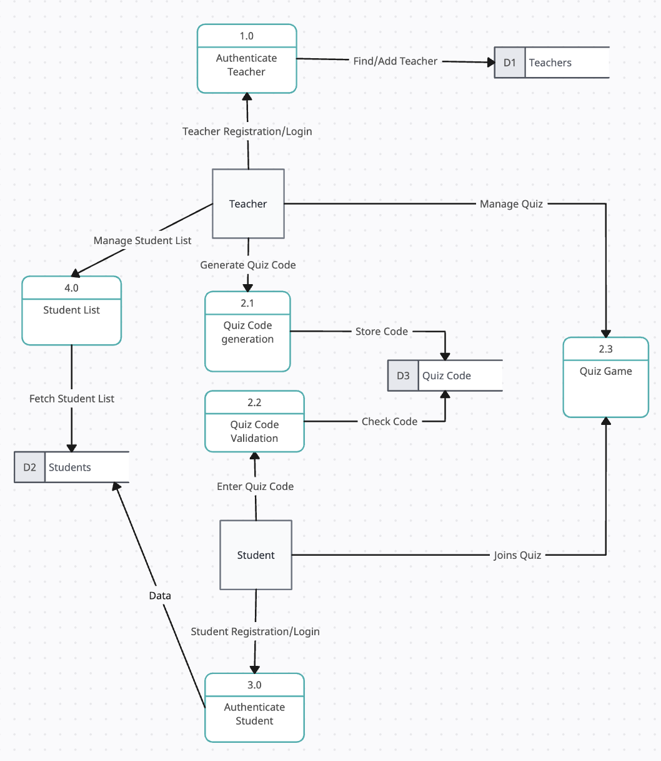

### **Level 2 DFD**

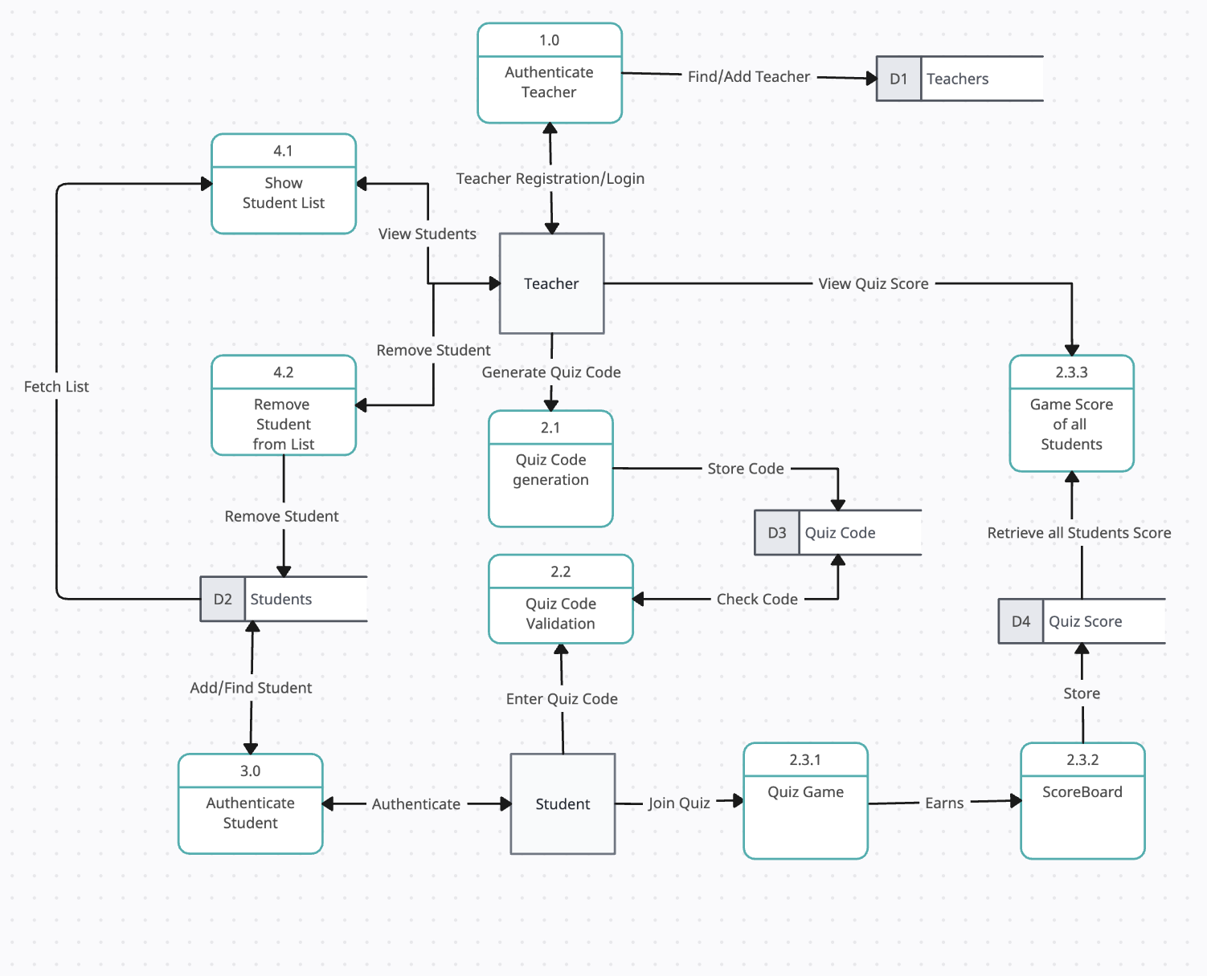

# Technologies to be used

## Front-end – ReactJs

## Back-end – NodeJs, ExpressJs

## Database - MongoDB

# Advantages of this Project

* Interactive learning experience.
* Real-time updates enhance engagement.
* Efficient data management with MongoDB.
* The application is designed to scale efficiently, accommodating a large number of users without compromising performance or user experience.

# Future Scope and further enhancement of the Project

* **Mobile Version -** As the usage of mobile devices for accessing such applications is on the rise. We will develop a dedicated mobile app version or making the web app mobile-friendly.
* **Offline Mode -** Consider adding an offline mode where users can download quizzes for later use, especially for users who might have limited or intermittent internet access.
* **Social Media Integration -** Allow users to share their quiz results on social media platforms. Integration with platforms like Facebook, Twitter, or Instagram can help in attracting more users and promoting your app.
* **AI Integration -** In the future, the quiz app plans to integrate AI for personalized learning paths, smart quiz recommendations, automated question generation, and advanced analytics. This AI integration aims to transform the app into an adaptive educational platform, enhancing the learning experience for both students and teachers.

# Conclusion

Quiz Application project aims to fill a crucial void in the education sector by providing a user-friendly platform for teachers to create and manage quizzes, and for students to easily participate and track their performance. With dedicated Teacher and Student Modules, along with seamless database integration, we strive to offer a comprehensive solution that enhances the interaction between educators and learners.